# قناة الجيمنج - The Gaming Channel

## Definition

**# Source**: **Chatgpt (GPT-5-Standard) at [8/27/2025]**

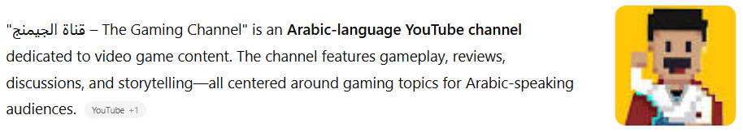

"قناة الجيمنج – The Gaming Channel" is an **Arabic-language YouTube channel** dedicated to video game content. The channel features gameplay, reviews, discussions, and storytelling—all centered around gaming topics for Arabic-speaking audiences. ([YouTube](https://www.youtube.com/%40TheGamingChannel360/videos?utm_source=chatgpt.com))

## Key Highlights

**# Source**: **Chatgpt (GPT-5-Standard) at [8/27/2025]**

* **Platform:** YouTube
* **Language:** Arabic
* **Content Style:** Gameplay commentary, storytelling, and insightful discussions about games
* **Recent Examples:**
  + *"من أين بدأ ال Lore في ألعاب الفيديو"* (“Where did game lore begin?”) – garnered ~14K views a few months ago ([YouTube](https://www.youtube.com/watch?v=IZ4bJIakIbg&utm_source=chatgpt.com))
* **General Tone:** Casual, informative—ideal for gamers who enjoy deeper conversations about game worlds and mechanics

## Summary Table

**# Source**: **Chatgpt (GPT-5-Standard) at [8/27/2025]**

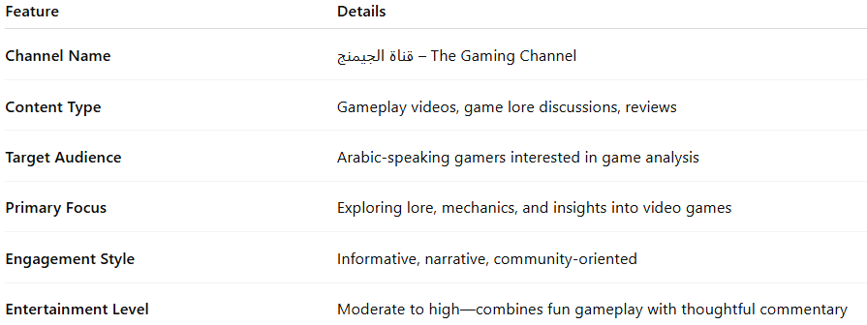

| **Feature** | **Details** |
| --- | --- |
| **Channel Name** | قناة الجيمنج – The Gaming Channel |
| **Content Type** | Gameplay videos, game lore discussions, reviews |
| **Target Audience** | Arabic-speaking gamers interested in game analysis |
| **Primary Focus** | Exploring lore, mechanics, and insights into video games |
| **Engagement Style** | Informative, narrative, community-oriented |
| **Entertainment Level** | Moderate to high—combines fun gameplay with thoughtful commentary |